SIMATS ENGINEERING
ASSESSMENT TOOL 2

COURSE NAME: Database Management Systems
COURSE CODE: CSA0508

COURSE OUTCOME COVERED

CO1: Analyze DBMS architecture, different data models, schema types, and design ER/EER diagrams, relational schemas for case-based scenarios by identifying entities and relationships. (BL1, BL2)

Activity Tool : Concept Mapping (Medium)
Assessment Tool Weightage: 35%

Dr

QUESTIONS Total Marks: 50
Q.No | Question | Bloom's Level | Marks
1 | Construct a concept map linking the following terms: DBMS, Schema, Instance, Data Model, ER Diagram, Entity, Attribute, Relationship. | BL2 – Understand | 5
2 | Create a concept map for the three-level ANSI/SPARC architecture showing data independence at each level. | BL2 – Understand | 5
3 | Map the relationship between file-based systems and database systems, highlighting the problems solved by DBMS. | BL2 – Understand | 5
4 | Design a concept map for ER diagram components: entity, weak entity, attribute types, relationship types, and participation constraints. | BL2 – Understand | 5
5 | Construct a concept map comparing Hierarchical, Network, and Relational data models with their key properties. | BL2 – Understand | 5
6 | Develop a concept map for the EER model showing how it extends the basic ER model with generalization, specialization, and aggregation. | BL2 – Understand | 5
7 | Create a visual concept map for the DBMS software architecture, illustrating the flow from user request to data retrieval. | BL2 – Understand | 5
8 | Map the data models discussed in CO1 to real-world applications and explain the suitability of each model. | BL2 – Understand | 5
9 | Construct a concept map for schemas and instances, showing how they relate to physical and logical data independence. | BL2 – Understand | 5
10 | Design a concept map for the roles and responsibilities in a DBMS environment: DBA, End User, Application Developer. | BL1 – Remember | 5

Code of Conduct:

I Abishana SK(192511242) (Name / Reg No) certify that this submission is my original work and that I have adhered to the guidelines specified for this assessment.
I understand that any violation of academic integrity rules will result in disciplinary action.

Signature of the student: Abishana S K

RUBRICS FOR CALCULATION:

Criteria | Weightage | Level 4 (Exemplary) | Level 3 (Proficient) | Level 2 (Developing) | Level 1 (Beginning)
Concept Identification | 25% | Identifies all key concepts from literature accurately and comprehensively | Identifies most key concepts with minor omissions | Identifies limited concepts; some are irrelevant or missing | Fails to identify essential concepts
Linkages | 25% | Establishes clear, meaningful, and accurate relationships between concepts | Shows correct relationships with minor gaps | Relationships are weak, unclear, or partially incorrect | No meaningful relationships established
Organization | 20% | Concepts are well-structured hierarchically with logical flow and grouping | Mostly organized with minor structural issues | Some organization but lacks clear hierarchy | No logical organization or structure
Integration of Literature | 20% | Integrates multiple studies effectively to show connections and comparisons | Shows some integration of literature | Limited integration; mostly isolated concepts | No integration of literature evidence
Clarity | 10% | Concept map is clear, neat, visually structured, and easy to interpret | Generally clear with minor readability issues | Clarity is reduced; difficult to interpret in parts | Poorly presented and hard to understand

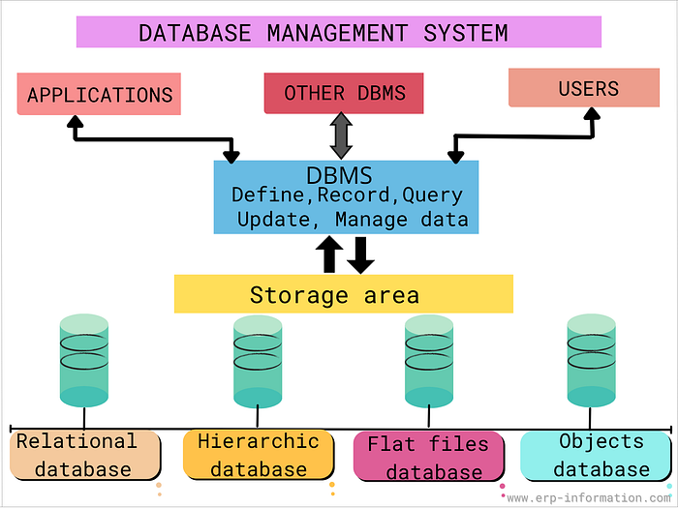

Solutions:

1 Core DBMS concepts. DBMS branches into a data model (which produces ER diagrams, made of entities, attributes, and relationships) and a schema (which has a corresponding instance — the actual data at any moment).

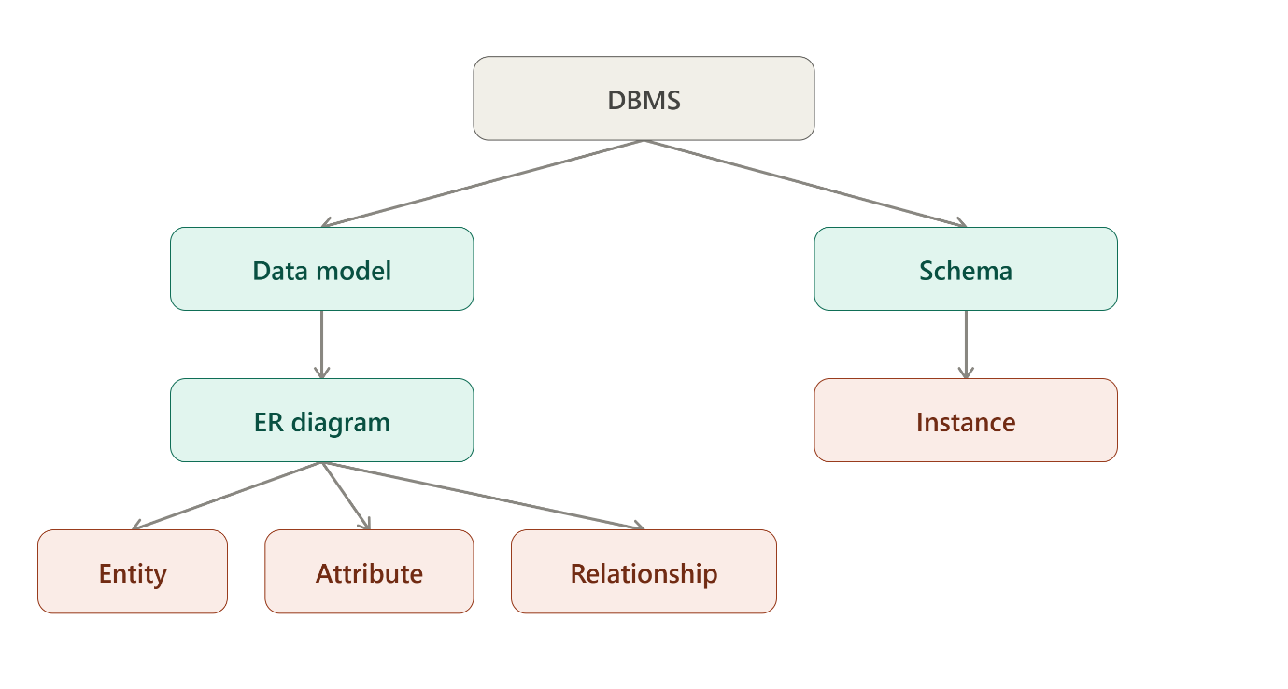

2 ANSI/SPARC three-level architecture. Each boundary between levels is where a type of data independence lives: changes to the internal (storage) level don't disturb the conceptual level, and changes to the conceptual level don't disturb external user views.
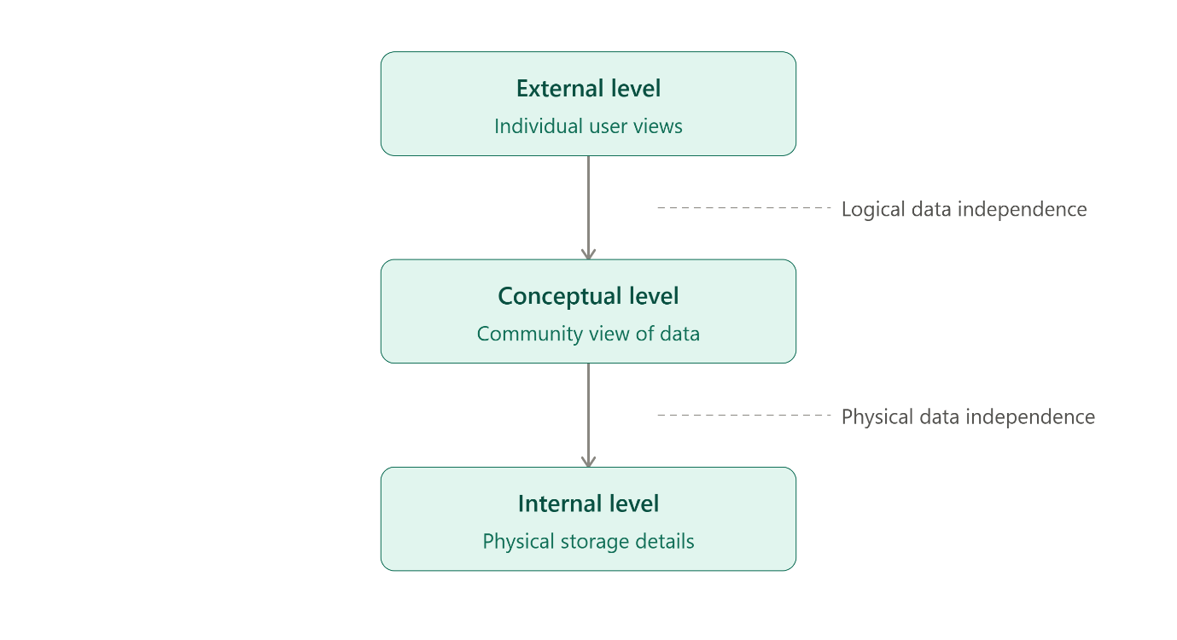
3 File-based vs. database systems. The left column lists the classic problems of file-based systems; the DBMS resolves each, producing the matching benefits on the right.

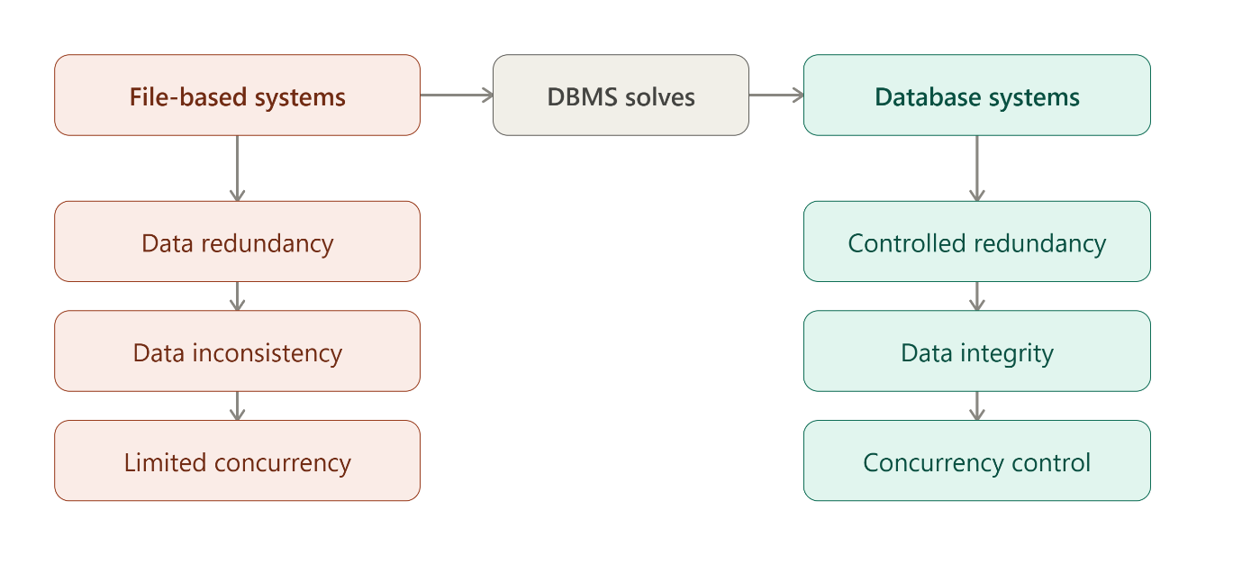
4 ER diagram components. Four core building blocks — entity, attribute, relationship, participation — each drilling into a specific detail below.

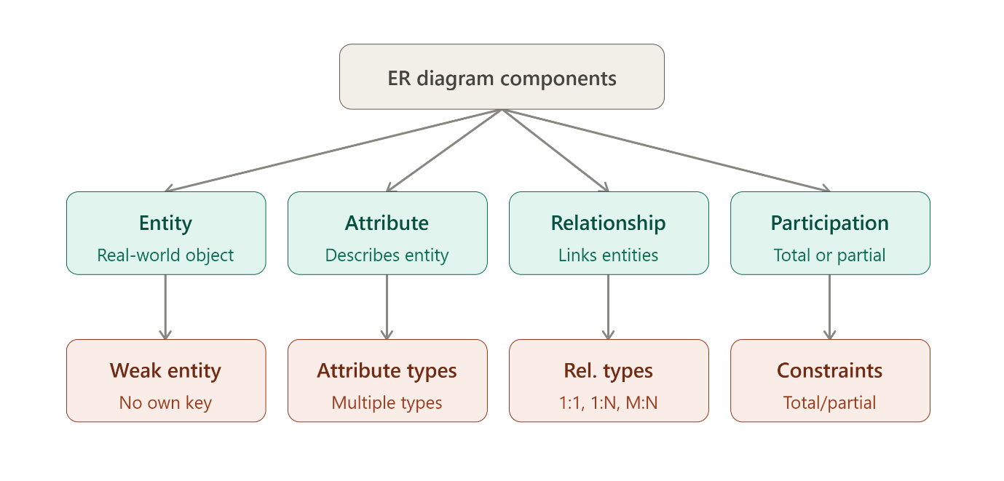
5 Data model comparison. Hierarchical uses tree-shaped records, network allows multiple parents per record (graph structure), and relational organizes everything into tables.

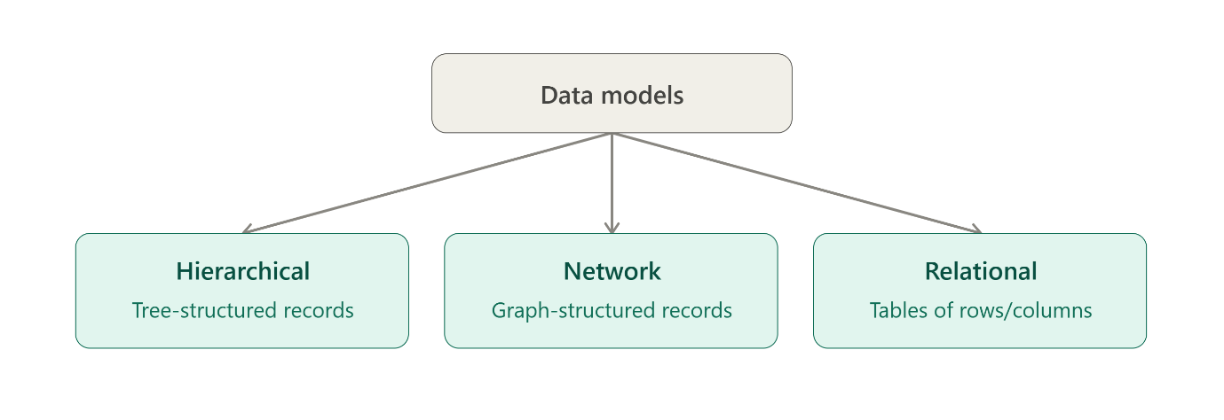
6 EER as an extension of ER. The EER model adds three modeling tools on top of the basic ER model: generalization (bottom-up combining), specialization (top-down dividing), and aggregation (treating a relationship as an entity).

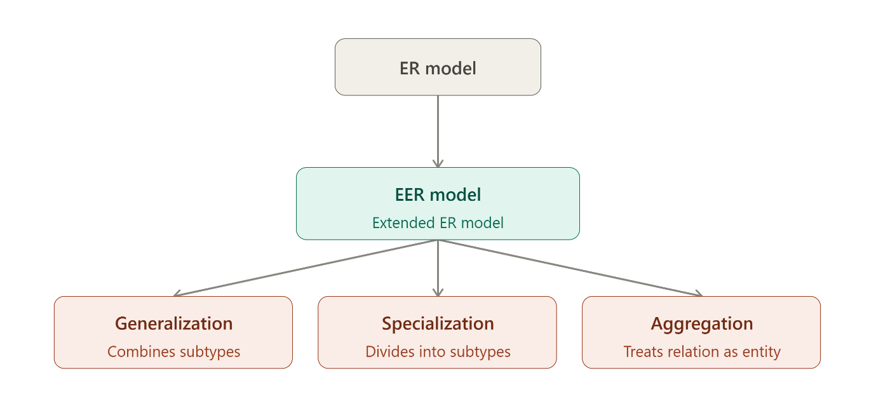

7 DBMS architecture flow. A request travels down through the interface, parser/optimizer, execution engine, and storage manager to reach the physical database, then results loop back up to the user (dashed path).

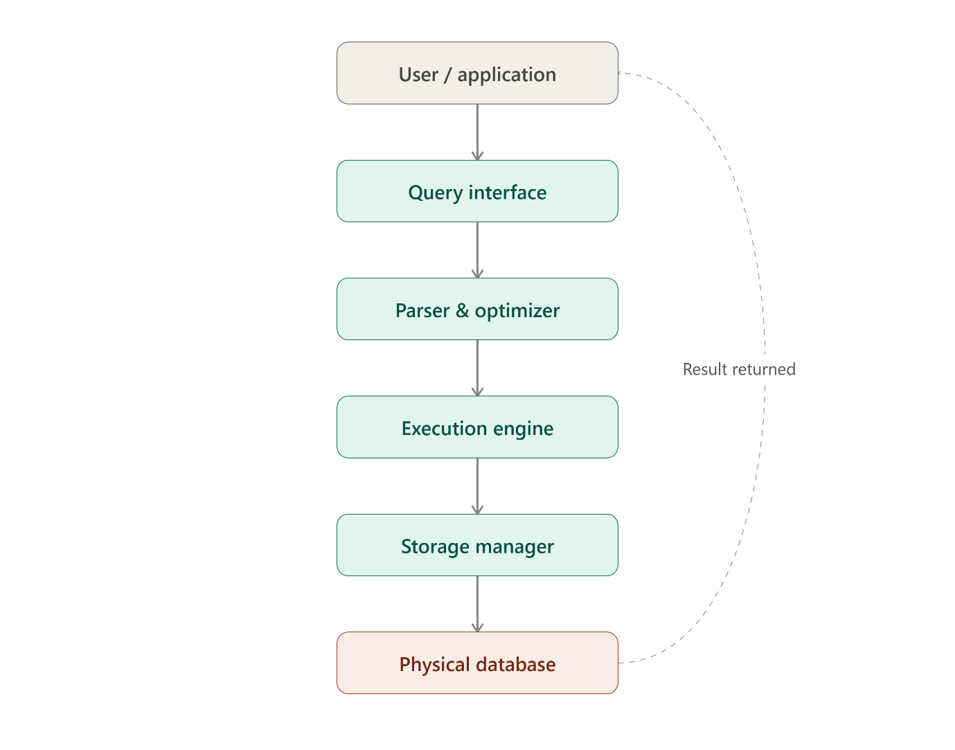

8 Data models mapped to applications. Each model suits different real-world needs: hierarchical for XML and file systems, network for telecom and CAD, relational for banking and business systems.

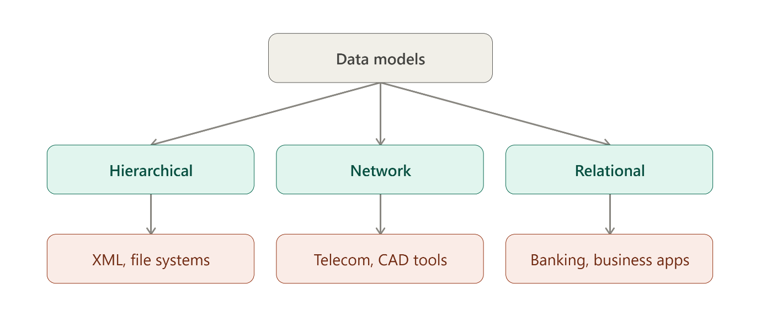
9 Schema, instance, and independence. The schema is where logical and physical data independence live (each shielding one level from changes below it); the instance is simply the data's state at a given moment, which changes constantly.

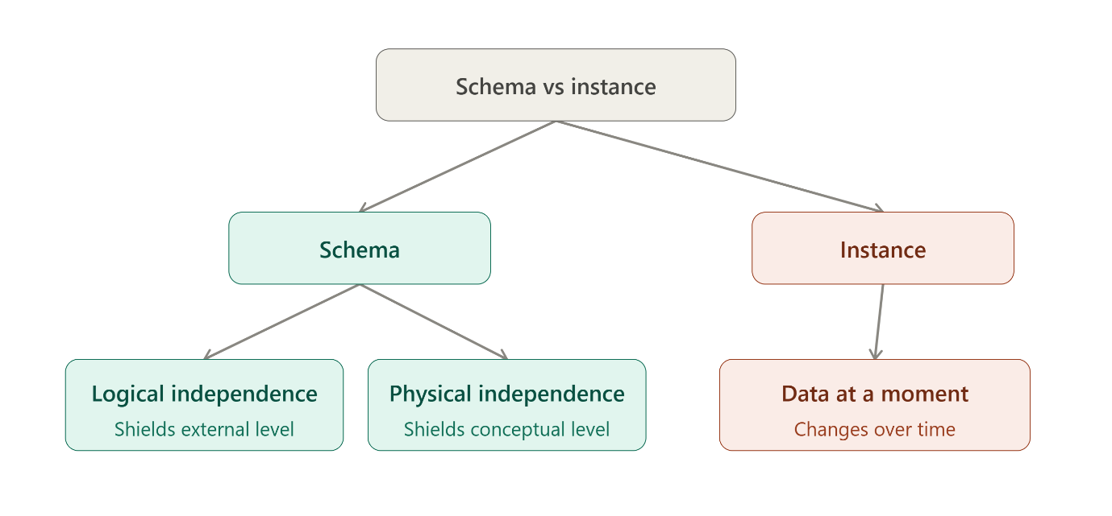
10 Roles in a DBMS environment. The DBA manages and secures the database, the end user queries and consumes data, and the application developer builds programs on top of it.

